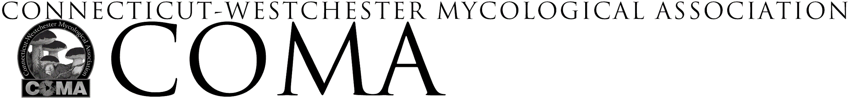
SYLVIA STEIN SCHOLARSHIP
-
APPLICATION

Applicant Information
Name
Address
Email address _________________________________ Phone
Event Information
Event title, date(s), host, sponsor, etc.

Project Summary

In a separate document please respond to the following 3 topics

- Your interest in mycology
- What qualities, accomplishments or factors make you a strong candidate for this scholarship
- Your past, current or planned involvement with COMA
Your response should be 250 to 500 typed, double-spaced words. Only completed applications that
are presented in an easily legible format will be considered. Please include your name and contact information on each page of your response. Directions for application submission are in the separate Guidelines document. Completed application including this page with your signature is to be
submitted to: kbrandt1@optonline.net
Event or Project Expense Summary
Outline total personal expenses, including other stipends, scholarships, or honorariums you expect
to receive. Submit a scholarship request amount and attach any supporting documents.
Category | Amount ($)
Total Event or Project Expense
Funding Requested

Scholarship Requirements
□ Lead one COMA walk
□ Submit an article to Spores Illustrated documenting your experience

Application Submitted by:
(please print clearly)
Signature: Date:

