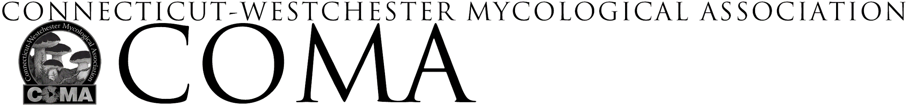
URSULA HOFFMAN SCHOLARSHIP
-
APPLICATION

Applicant Information
Name
Address
Email address _________________________________ Phone

In a separate document please respond to the following 3 topics

- Your interest in mycology
- What qualities, accomplishments or factors make you a strong candidate for this scholarship
- Your past, current or planned involvement with COMA

Your response should be 250 to 500 typed, double-spaced words. Only completed applications that are presented in an easily legible format will be considered. Please include your name and contact information on each page of your response. Directions for application submission are in the separate Guidelines document.

Please indicate if you wish to attend the foray as:
- Day visitor
- Single-overnight stay
- Full foray

Scholarship Requirements
The only requirement of the scholarship will be for the recipient to assist in the sorting room under the direction of the Chief Mycologist at the Clark Rogerson Foray. It is expected that if the recipient is attending the full foray event that they will volunteer two afternoons in the sorting room. COMA will keep the recipient’s identity anonymous if so desired.

Completed application including this page with your signature is to be submitted to: kbrandt1@optonline.net

Applications must be received no later than August 1st

Application Submitted by:
(please print clearly)
Signature: Date:

