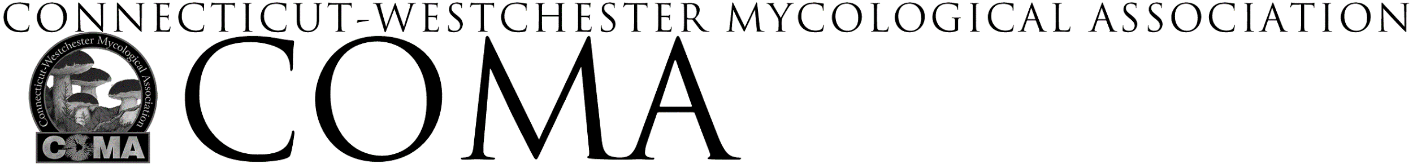URSULA HOFFMANN SCHOLARSHIP
GUIDELINES

The Connecticut Westchester Mycological Association, established in 1975, has created the Ursula Hoffmann Scholarship through the generous donation of an anonymous donor. Ursula Hoffmann, Ph.D. was a Professor of Language and Literature at Lehman College in New York City. She was an avid mycologist, an expert on orchids, and for many years created the mushroom species list for COMA's annual Clark Rogerson Foray.

The intent of the scholarship is to support the recipient’s attendance at COMA’s annual Clark Rogerson Foray. Recipients should have a demonstrated interest in any aspect of mycology.
The Clark Rogerson Foray will be held on Labor Day weekend at Camp Hemlocks in Hebron, CT.

The only requirement of the scholarship will be for the recipient to assist in the sorting room under the direction of the Chief Mycologist at the Clark Rogerson Foray. It is expected that if the recipient is attending the full foray event that they will volunteer two afternoons in the sorting room. COMA will keep the recipient’s identity anonymous if so desired.

Scholarship Guidelines
- The scholarship will cover the full registration fee for the Clark Rogerson Foray – this includes housing and meals.
- Applicants can opt to attend the full foray, a single overnight stay, or as a day visitor. The scholarship will cover whatever option the applicant chooses.
- Individuals may request funding by submitting a completed Ursula Hoffmann Scholarship application.
- The applicant must be a current member of COMA at the time of application.
- Applications must be received no later than August 1.
- COMA does not assume liability for activities associated with this scholarship.
- An applicant’s personal financial situation is neither a requirement for eligibility nor a factor in scholarship determination.

Applications and guidelines may be downloaded at: https://www.comafungi.org/learn/scholarships/

Applications are to be submitted to: kbrandt1@optonline.net

